./

Learning Report – Applied System Development Life Cycle and Software Testing



|  |  |  |  |  |  |
| --- | --- | --- | --- | --- | --- |
| **Ver. Rel. No.** | **Release Date** | **Prepared. By** | **Reviewed By** | **To be approved By** | **Remarks/Revision Details** |
| 1 |  | Name/PS No | Name/PS No | Module Owner Name | Comments |
| 2 | 15/02/21 |  |  |  |  |
| 3 |  |  |  |  |  |
|  |  |  |  |  |  |
|  |  |  |  |  |  |

**Document History**

Table of Contents

Table of Figures 3

Table of Tables 4

ACTIVITY 1: SYSTEM/ SOFTWARE DEVELOPMENT 4

**INTRODUCTION** 4

**MY PRODUCT: “Name ”** 6

**SWOT ANALYSIS** 7

**REQUIREMENTS** 7

**DESIGN** 8

HIGH LEVEL DESIGN 8

LOW LEVEL DESIGN 11

**TEST PLANS** 13

**REFERENCES** 15

ACTIVITY 2: AGILE METHODOLOGY 15

**THEME** 15

**EPIC** 15

**USER STORY** 16

**REFERENCES** 17

APPENDIX: 17

## Table of Figures

Figure 1 CLASS DIAGRAM(HIGH LEVEL) 10

Figure 2 USE CASE DIAGRAM (HIGH LEVEL) 11

Figure 3 ACTIVITY DIAGRAM (HIGH LEVEL) 12

Figure 4 USE CASE DIAGRAM (LOW LEVEL) 12

Figure 5 ACTVITY DIAGRAM (LOW LEVEL) 13

Figure 6 BLOCK DIAGRAM 13

Figure 7 COMPONENT DIAGRAM (HIGH LEVEL) 22

Figure 8 ACTIVITY DIAGRAM (high level) 23

[Figure 9 ACTIVITY DIAGRAM (LOW LEVEL) 24](https://lnttsgroup.sharepoint.com/sites/GEA/Global%20Engineering%20Academy/GEA%20Insights/Genesis/Shared%20Documents/Submission/MYSORE/2009MYSEMB/Foundation/Applied%20SDLC%20with%20Software%20Testing/99002439/FINAL.docx#_Toc52177322)

Figure 10- ACTIVITY DIAGRAM (LOW LEVEL) 24

Figure 11 TEST PLAN 25

Figure 12 GIT 27

Figure 13 GIT ISSUES 28

Figure 14 GIT COMMITS 1 28

Figure 15 GIT COMMIT 2 29

Figure 16 GIT 30

Figure 17 GIT MAKE 31

Figure 18 GIT MAKE 2 31

Figure 19 GIT BUILD 32

Figure 20 GIT CODE QUALITY 32

## Table of Tables

Table 1 AGING 6

Table 2 GRADING COST 6

Table 3 REQUIREMENTS 8

Table 4 HIGH LEVEL TEST PLAN 15

Table 5 LOW LEVEL TEST PLAN 16

Table 6 USER STORIES 17

Table 7 AGING 19

Table 8 GRADING COST 19

Table 9 REQUIREMENTS 21

Table 10 USER STORIES 27

Requirements

## Introduction

Calculator is a scientific device which is used to perform calculations,like arithmetic calculations,logical calculations, exponential calculations,trignometic calculations and much more. In some calculators,we can also insert equations in raw format and we can obtain the results.Calculators are very handy and portable.They can be easily brought to any location as they come very handy.Using calculator,we can do simple calculations as well as scientfic calculations also.Even scientists will use these calculators to come to conclusions of complex calculations. Calculators are very extensively used in statistics to find out results of present and also perform calculations for prediction of future trends.

## Research

Calculators range from few hundreds to few thousands of rupees based on the features they provide. Simple calculators can range from few hundreds, and scientific calculators are a bit more than Rs 700.

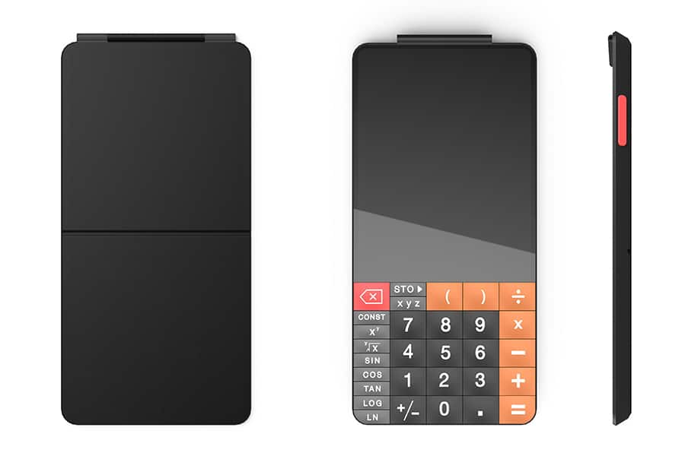

These touch calculators can range from thousands of rupees. But they offer a lot more features than the standard scientific calculators.

## These touch calculators can display graphs in pictorial representation form

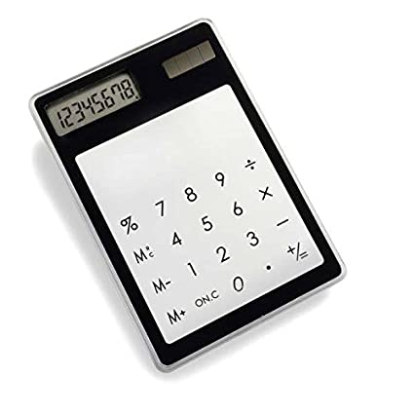

## Defining Our System

As the name describes that it is a smart calculator, it can do complex operations in less time and is user friendly we can do various type of operations in it. It has inputs for arithmetic calculations,temperature conversion,dimension conversion and a lot more.

## SWOT ANALYSIS

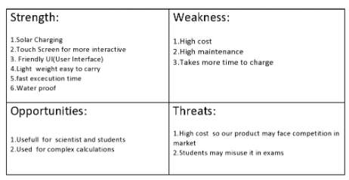

# 4W's and 1'H

## Who:Everyone can use this calculator especially scientist and students.

## What:Its a smart scientific calculator.

## When:For fast,efficient and complex calculations.

## Where:Calculations,Statistics(comparing the previous data with present data).

## How:Easy to user interface.

# Detail requirements

## High Level Requirements:

* **Arithmetic**
* **Area calculator**
* **Complex operation**
* **Trigonometric calculation**
* **Temperature conversion**
* **Volume calculation**
* **Discount calculation**
* **Interest calculation**
* **Length converter**
* **Square root function**
* **Matrix calculation**
* **Factorial calculation**
* **HCF**
* **LCM**

## Low level Requirements:

* **Addition, subtraction, multiplication, division modules**
* **Length, breadth, height**
* **Fahrenheit, Celsius temperature values**
* **BODMAS**
* **formulae for trignometric calculations**
* **Allow Digits 0-9.**

**LOW LEVEL REQUIREMENT CLASS DIAGRAM(VOLUME CALCULATOR):**

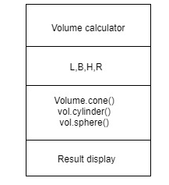

USECASE DIAGRAM (SQUAREROOT CALCULATOR):

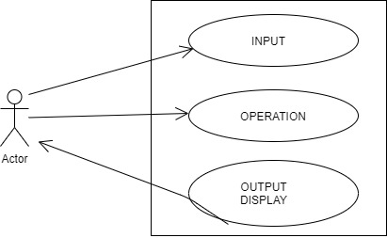

HIGH LEVEL REQUIREMENT OBJECT DIAGRAM (VOLUME CALCULATOR):

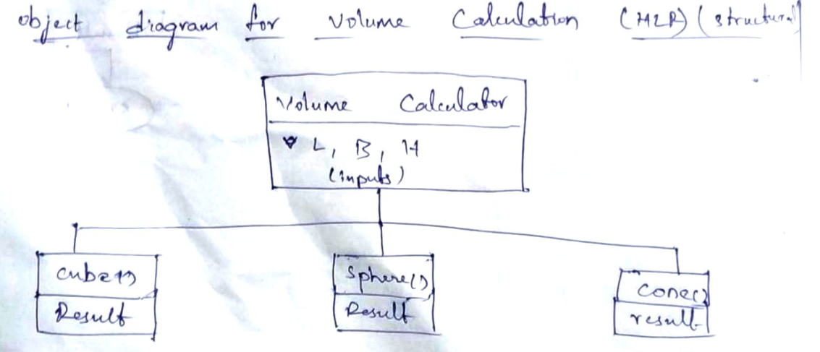

TEST PLAN:

